Home Education Programme – OFF THE BLOCKS LOGIN INSTRUCTIONS
The British Swimming ‘Off the Blocks’ platform is designed to provide information & support to teachers, coaches, parents and swimmers across the country.
The resources have been produced to help up skill the teachers/coaches and educate the next generation of swimmers by providing a range of simple and relevant materials.
The resource takes the form of a responsive micro-website which resizes for desktop, tablet and mobile view, providing video examples of elite male & female athletes, plus age group male and female exemplars.
Access Instructions for swimmers and parents
Visit https://offtheblocks.info/. This will take you to the landing page below.
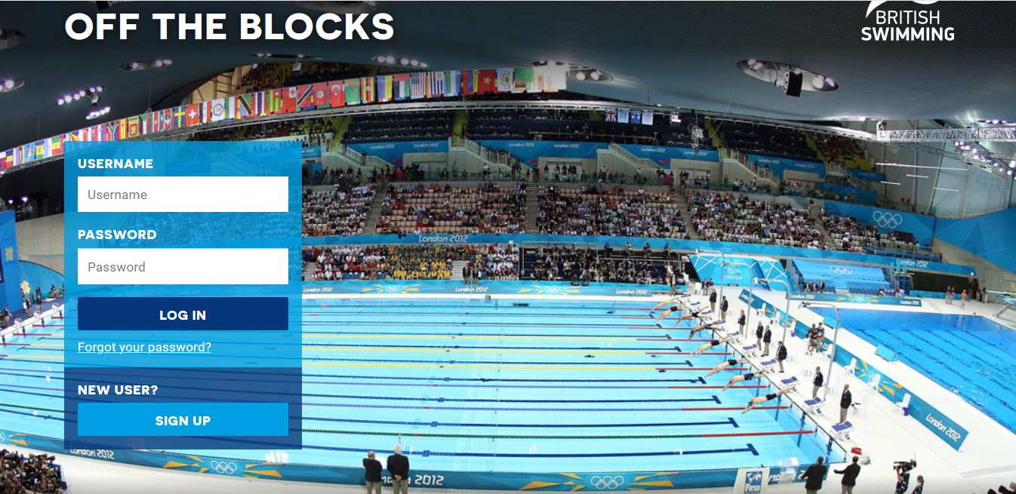
Under the ‘New USER’ section, click on the ‘sign-up’ link. This will take you to the account creation page below. Please follow the instructions and complete the sign-up form (make a note of your username and password).
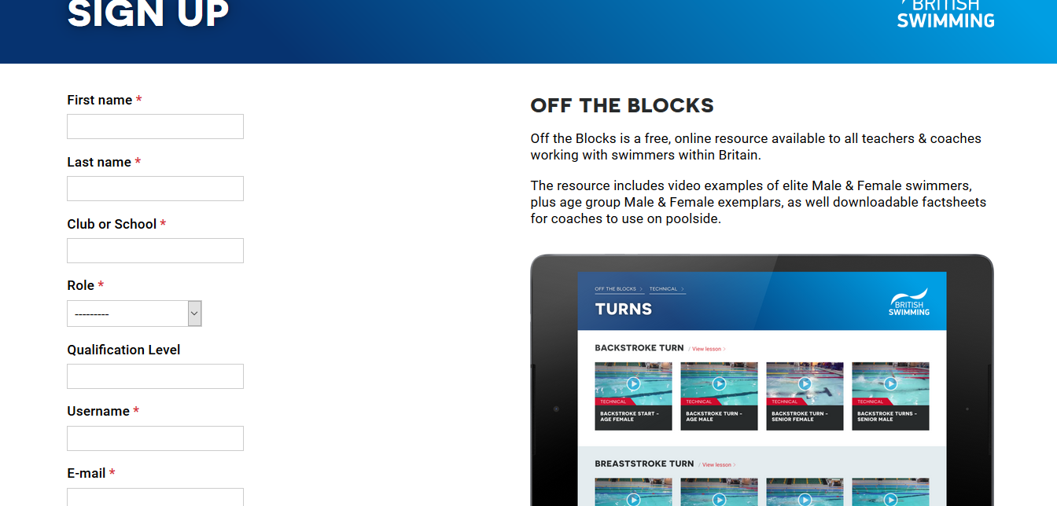
Once you have submitted this sign-up request, it will take few days to for you to receive access confirmation from British Swimming. You will then have access to the site the via login form on the landing page.
Over the coming days I will create a suggested completion schedule which will ensure swimmers have accessed all the relevant topics that are available.

