**BRITISH SWIMMING ISOLATION TRAINING STRATEGIES**

19th March 2020

The purpose of the following document is to provide some **practical guidelines on land training strategies to support strength/power, and cardiovascular development in the events of:**

***Your normal training base shutting down***

***Social distancing from others / home training***

***This strategy document is not intended to be exhaustive.***

***The overarching purpose is to help provide a structure for athlete, swim coach, and support staff to modify based on an individual’s needs***

**CONTENTS**

1. Structuring your training week

2. Home/ distance-based strength/ power equipment recommendations and price points

3. Sample distance-based strength/ power training sessions (Bodyweight & Band Based)

4. Home/ distance-based cardiovascular equipment recommendations and price points

5. Sample distance-based cardiovascular training sessions

6. Distance based recovery modalities

**STRUCTURING YOUR TRAINING WEEK**

At the time of writing this document **the majority of programme athletes still have access to a pool and high-performance gym within their training environment.**

However, as the landscape changes **we may be faced with having to train at home without a pool.**

The schedule below outlines how a weeks training structure may look based on access to a **training centre** or **training at home.**

Please note that the British Swimming medical team do not advise the use of public gyms where the hygiene risk cannot be controlled and there is risk of exposure to large groups of people.

|  |  |  |  |  |  |  |  |
| --- | --- | --- | --- | --- | --- | --- | --- |
| **DAY** | **Monday** | **Tuesday** | **Wednesday** | **Thursday** | **Friday** | **Saturday** | **Sunday** |
|
|
| **AM.** | **Swim OR** **Home based CV** | **Swim OR** **Home based CV** | **Swim OR** **Home based CV** | **Swim OR** **Home based CV** | **Swim OR** **Home based CV** | **Swim OR** **Home based CV** | Spend some time outside but avoid crowded spaces! |
| **Gym OR** **Home based gym** |  | **Gym OR** **Home based gym** |  | **Gym OR** **Home based gym** |  |
| Individual capacity or Yoga/ Pilates |  | Individual capacity or Yoga/ Pilates |  | Individual capacity or Yoga/ Pilates |  |
| **P.M** | **Swim OR** **Home based CV** | **Swim OR** **Home based CV** |  | **Swim OR** **Home based CV** | **Swim OR** **Home based CV** |  |  |
|  |  |  |  |  |  |  |
|  |  |  |  |  |  |  |

***The table above is a general guideline only. The final structure of your training week should be agreed between the athlete, Swim Coach, and Strength & Conditioning Coach.***

It is likely that support staff will run remote training sessions via streaming services if training becomes home based, this will provide structure to your training day/ week. **In the event where sessions cannot be supervised, sessions should be distributed across the day/ week as they would be under normal training conditions.**

**HOME/ DISTANCE BASED STRENGTH/ POWER EQUIPMENT RECOMMENDATIONS**

In the event of your training centre closing or having to practice social distancing/ self-isolation there is equipment that can be purchased that will minimise the disruption to your strength/ power training.

Your home-based S&C coach will provide individualised programming to support your strength/ power development, however having access to the items below will greatly improve the flexibility of the programming options. **Items 1-3 on the list below are recommended for all athletes.**

**Item 4 or equivalent may be purchased where athletes require greater external lower body loading** i.e. leg dominant events such as breaststroke or those that have attained high levels of lower body strength (greater than 1.5 x BW back squat or deadlift).

|  |  |  |  |
| --- | --- | --- | --- |
| **Item Number** | **Item** | **Website/ Retailer** | **Price Point** |
| 1 | [Doorway Pull Up Bar](https://www.amazon.co.uk/Body-Sculpture-Total-Upper-Workout/dp/B003H9LK14/ref=sr_1_16?crid=YX184G1OEZ0U&dchild=1&keywords=doorway+pullup+bar&qid=1584435782&sprefix=doorway+pull%2Caps%2C156&sr=8-16) | Amazon | £17.34 |
| 2 | [Gym Rings](https://www.amazon.co.uk/ALPIDEX-gymnastic-including-fastening-markings/dp/B07SZ89M7F/ref=sr_1_6?crid=9X6EPMTHJDE1&dchild=1&keywords=gymnastic+rings&qid=1584441295&sprefix=gyman%2Caps%2C164&sr=8-6) | Amazon | £24.99 |
| 3A | [Resistance Bands](https://www.strengthshop.co.uk/mobility-recovery/resistance-bands/strength-shop-premium-latex-resistance-bands-41-set-2-each-no-0-5-1-2.html) | Strengthshop | £49.99 |
| 3B | [Resistance Bands with Hip Band](https://www.strengthshop.co.uk/mobility-recovery/resistance-bands/gift-package-warmup.html) | Strengthshop | £28.49 |
| 4 | [Weighted Vest 20kg](https://www.strengthshop.co.uk/weighted-vest-adjustable-1-20kg.html) | Strengthshop | £79.99 |

*If you require additional loading and can’t access/ budget for a weighted vest it is possible to substitute a rucksack with heavy books!

**\*\*More comprehensive home gym equipment packages are available but are in limited supply at the time of writing. If interested please contact Andy Elkins, Senior Strength & Conditioning Coach, British Swimming at** [**andy.elkins@eis2win.co.uk**](mailto:andy.elkins@eis2win.co.uk)

**SAMPLE DISTANCE-BASED STRENGTH POWER SESSIONS**

Based on the **equipment list in the previous section**, the programme below can be used to provide a strength/ power stimulus in the absence of your regular training environment. I**ntensity of all exercises can be increased using a weighted vest (item 4) or increasing eccentric tempo to 5-6 seconds.**

**The following programmes serve only as a guide based on recommended home equipment. *Consult with you S&C coach on what is appropriate for you based on the equipment above and other kit you may have access to.***



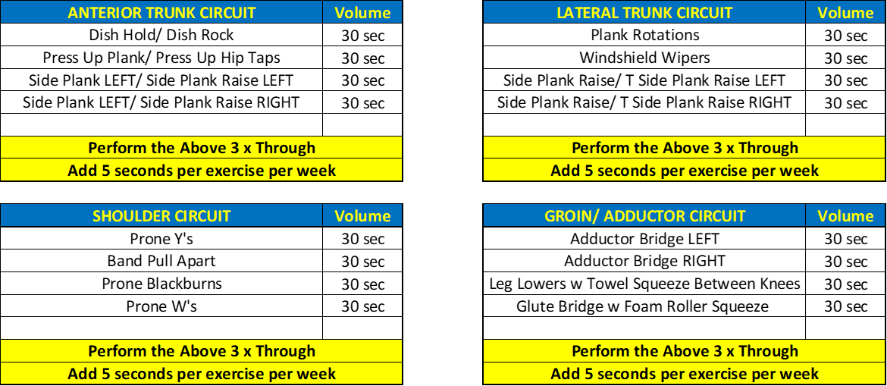

-Complete the programme above 2-3 x per week

-Each session should be preceded by a warmup that is specific to your individual needs

-Pick one exercises from each section (options A-C) and follow the weekly progression criteria

-Each session should be followed by a local muscular endurance block (Trunk, Shoulder, Groin) relevant to your specific needs

If you only have access to **bands only**, the following programme can be completed to provide a strength/ power stimulus in the event pf home-based training.



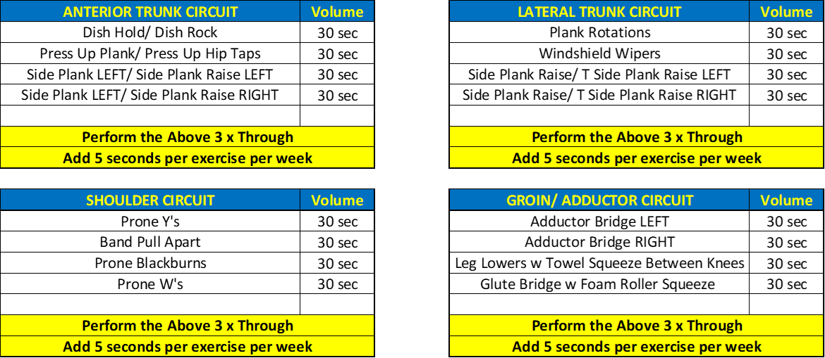

-Complete the programme above 2-3 x per week

-Each session should be preceded by a warmup that is specific to your individual needs

-Pick one exercises from each section (options A-C) and follow the weekly progression criteria

-Each session should be followed by a local muscular endurance block (Trunk, Shoulder, Groin) relevant to your specific needs

**HOME/ DISTANCE-BASED CARDIOVASCULAR EQUIPMENT RECOMMENDATIONS**

In the event of not being able to gain access a pool or gym **there is the option to hire CV equipment for home delivery.** This gives the option to **use cross training to maintain/ progress your energy system development whilst you may be out of the water.**

***Consult with your coach, physiologist and S&C coach on how land based CV sessions are structured / periodised across the training week.***

Below is a list of recommended equipment and hire rates. **Note that the minimum hire term on most kit is 3 months. You should discuss with your coach and S&C coach on how you may use the kit over the three-month period to improve your energy system development over the 12-week period.**

|  |  |  |  |
| --- | --- | --- | --- |
| **Item**  **No.** | **Item** | **Website** | **Price** |
| 1 | [Concept 2 Rower](https://www.indoorsportservices.co.uk/concept2-indoor-rower-hire.html) | Indoorsportservices.co.uk | £169 for 3 months |
| 2 | [Rogue Echo Bike](https://www.indoorsportservices.co.uk/rogue-echo-bike-hire.html) | Indoorsportservices.co.uk | £195 for 3 months |
| 3 | [Concept 2 Ski Erg](https://www.indoorsportservices.co.uk/checkout/cart/) | Indoorsportservices.co.uk | £169 for 3 months |
| 4 | [Turbo Trainer Hire (Requires a compatible bike)](https://turbotrainerhire.co.uk/collections/wheel-on-turbo-hire) | turbotrainerhire.co.uk | From £40 per month |
| 5* | [Peloton App 90 Day Free Trial](https://www.onepeloton.co.uk/app) | onepeloton.co.uk/app | Free for 90 days |

**\* Peloton are currently offering a 90 day free trail to their circuit training app. If this is chosen as a viable option for your cardiovascular conditioning, you should consult with your S&C coach on which circuits are most appropriate for you.**

**MONITORING YOUR LAND BASED CV SESSIONS**

A greater volume of cross training through lack of pool access brings about some challenges:

***Pacing:*** You may over/ under exert yourself if unfamiliar with a specific modality of exercise

***Targeting Specific Outcomes:*** Whilst you are all familiar with what using specific energy systems feels like in the water. This may be somewhat alien to you on land. In order to make your training as specific as possible it is recommended that you **purchase a heart rate monitor** if you do not already own one.

[**The Wahoo TICKR Heart Rate Monitor retails at £29.99**](https://www.wiggle.co.uk/wahoo-tickr-heart-rate-monitor/?lang=en&curr=GBP&dest=1&sku=5360657087&kpid=5360657087&utm_source=google&utm_term=&utm_campaign=Shopping+-+All+Products&utm_medium=base&utm_content=mckv|seDcDqclf_dc|mcrid|295293415336|mkw||mmt||mrd|5360657087uk|mslid||&mkwid=seDcDqclf_dc&pcrid=295293415336&prd=5360657087uk&pgrid=58853027266&ptaid=pla-523616365388&gclid=EAIaIQobChMI4KyQsfmm6AIVw4XVCh33ogTWEAQYASABEgIK_vD_BwE)

Purchasing a compatible heart rate monitor also provides the following advantages:

**Competition against your teammates through use of Strava**

**Sessions to be prescribed via a training app and results sent back to your coaches/ support staff**

[](https://www.strava.com/)

A further source of suitable cycling based training sessions is the Global Cycling Network YouTube Channel – [Train with GCN](https://www.youtube.com/watch?v=BBVYkHH98Hc&list=PLUdAMlZtaV12qqCZBR7qqYI58TfEADr-d). Again, swimmers should consult with their coaches and S&C coach to determine which sessions are most appropriate to their needs

[](https://www.youtube.com/watch?v=BBVYkHH98Hc&list=PLUdAMlZtaV12qqCZBR7qqYI58TfEADr-d)

**DISTANCE BASED CARDIOVASCULAR TRAINING SESSIONS**

**If you have access to any of the home-based exercise equipment the sessions below may be used to address energy system training requirements. This list is not exhaustive, *all home based CV sessions should be agreed between athlete, Swim Coach, and Strength & Conditioning Coach, & physiology team.***

***INTERVAL BASED BIKE, ERGO, SKI ERG OPTIONS:***

|  |  |  |  |  |  |
| --- | --- | --- | --- | --- | --- |
| **INTERVAL OPTIONS** | | | | | |
| **\* warm up and cool down for 5 mins for each session type** | | | | | |
| **Work Time** | **Rest Time** | **Number of Reps** | **Sets** | **Rest Between Sets (Mins)** | **Session Time** |
| 30 | 30 | 12 | 3 | 3 | 39 |
|  |  |  |  |  |  |
| **Work Time** | **Rest Time** | **Number of Reps** | **Sets** | **Rest Between Sets (Mins)** | **Session Time** |
| 60 | 60 | 10 | 2 | 1 | 41 |
|  |  |  |  |  |  |
| **Work Time** | **Rest Time** | **Number of Reps** | **Sets** | **Rest Between Sets (Mins)** | **Session Time** |
| 30 | 15 | 15 | 3 | 3 | 37 |
|  |  |  |  |  |  |
| **Work Time** | **Rest Time** | **Number of Reps** | **Sets** | **Rest Between Sets (Mins)** | **Session Time** |
| 45 | 15 | 10 | 3 | 3 | 33 |
|  |  |  |  |  |  |
| **Work Time** | **Rest Time** | **Number of Reps** | **Sets** | **Rest Between Sets (Mins)** | **Session Time** |
| 30 | 60 | 10 | 2 | 3 | 33 |
|  |  |  |  |  |  |
| **INTERVAL LADDERS** | | | | | |
| **Rung** | **Work Time (S)** | **Rest Time (S)** | **Accumulated Time (Mins)** | | **Session Time (Mins)** |
| 1 | 15 | 15 | 30 | 0.5 | 32 |
| 2 | 30 | 30 | 90 | 1.5 |
| 3 | 60 | 60 | 210 | 3.5 |
| 4 | 30 | 30 | 270 | 4.5 |
| 5 | 15 | 15 | 300 | 5.0 |
| 6 | 30 | 30 | 360 | 6.0 |
| 7 | 60 | 60 | 480 | 8.0 |
| 8 | 30 | 30 | 540 | 9.0 |
| 9 | 15 | 15 | 570 | 9.5 |
| 10 | 30 | 30 | 630 | 10.5 |
| 11 | 60 | 60 | 750 | 12.5 |
| 12 | 30 | 30 | 810 | 13.5 |
| 13 | 15 | 15 | 840 | 14.0 |
| REST | 120 |  | 960 | 16.0 |
| **REPEAT X 2** | | | | 32 |

***INTERVAL BASED BIKE, ERGO, SKI ERG OPTIONS:***

|  |  |  |
| --- | --- | --- |
| **STEADY STATE OPTIONS** | | |
| **\* warm up and cool down for 5 mins for each session type** | | |
| **30 minute metres challenge * Warm up & cool down for 5 mins** | | |
| **Pick a moderate resistance and get as far as possible in 30 minutes- Record your score below** | | |
| **Date** | **Resistance** | **Metres** |
|  |  |  |
|  |  |  |
|  |  |  |
|  |  |  |
|  |  |  |
|  |  |  |

|  |  |  |  |
| --- | --- | --- | --- |
| **3 x 2km challenge** | | | |
| **Pick a moderate resistance and complete 2k as fast as possible** | | | |
| **Rest 3 minutes between each 2k and record your scores below** | | | |
| **Date** | **2k Time 1** | **2k Time 2** | **2k Time 3** |
|  |  |  |  |
|  |  |  |  |
|  |  |  |  |
|  |  |  |  |
|  |  |  |  |
|  |  |  |  |

**3 Minute Challenge**

**3**

|  |  |  |  |  |  |  |
| --- | --- | --- | --- | --- | --- | --- |
| **3 x 3 Minute Challenge** | | | | | | |
| **Pick a moderate resistance and complete 3 x 3 minute reps aiming to accumulate as much distance as possible on each rep. Complete 2 sets for a total of 6 reps.** | | | | | | |
| **Rest 90 seconds between reps and 3 minutes between sets.** | | | | | | |
| **Date** | **Rep 1 Distance** | **Rep 2 Distance** | **Rep 3 Distance** | **Rep 4 Distance** | **Rep 5 Distance** | **Rep 6 Distance** |
|  |  |  |  |  |  |  |
|
|  |  |  |  |  |  |  |
|
|  |  |  |  |  |  |  |
|
|  |  |  |  |  |  |  |
|

**x 3 Minute Challenge**

**CIRCUIT TRAINING OPTIONS**

If you are **unable to access a piece of CV equipment at home circuit training provides an effective means with almost endless variety.** Things to consider are **picking appropriate methods that don’t put you at risk of injury** and the equipment you have to hand.

**Your Strength & Conditioning Coach can design your circuit programmes that are bespoke to your capability and equipment list**. However, 2 examples are provided below. Each of these sessions require no equipment, just your body.

**\*\*Your S&C coach may look to set up group circuit classes over skpe/ face time/ conferencing software\*\***

|  |  |  |
| --- | --- | --- |
| **CIRCUIT A** | | |
| **EXERCISE** | **WORK TIME (SECONDS)** | **REST TIME (SECONDS)** |
| JUMP LUNGES | 45 | 15 |
| V-UPS | 45 | 15 |
| SQUAT HOPS | 45 | 15 |
| DOWN DOG PLANKS | 45 | 15 |
| MOUNTAIN CLIMBERS | 45 | 15 |
| SPRINTER SIT UP | 45 | 15 |
| HIGH KNEE RUNNING ON SPOT | 45 | 15 |
| PLANK ROTATIONS | 45 | 15 |
| SQUAT THRUST | 45 | 15 |
| ELBOW TAP & REACH | 45 | 15 |
| ROCK BACK TO STAND | 45 | 15 |
| **REST BETWEEN CIRCUITS (SECONDS)** | **120** | |
| **NUMBER OF CIRCUITS** | **3** | |
| **TOTAL SESSION TIME** | **33** | |
| **\* WARM UP WITH 5 MINS LIGHT CV & MOBILITY** | | |

|  |  |  |
| --- | --- | --- |
| **CIRCUIT B** | | |
| **EXERCISE** | **WORK TIME (SECONDS)** | **REST TIME (SECONDS)** |
| MOUNTAIN CLIMBER WITH TWIST | 45 | 15 |
| TUCK UP | 45 | 15 |
| BROAD JUMP WITH JOG BACK | 45 | 15 |
| DOWN DOG ELBOW TAPS | 45 | 15 |
| BURPEE | 45 | 15 |
| LEG KICKS IN DISH | 45 | 15 |
| WIDE MOUNTAIN CLIMBERS | 45 | 15 |
| PLANK ROTATIONS | 45 | 15 |
| ROCK BACK TO STAND | 45 | 15 |
| WINDSHIELD WIPERS | 45 | 15 |
| JUMP LUNGES | 45 | 15 |
| **REST BETWEEN CIRCUITS (SECONDS)** | **120** | |
| **NUMBER OF CIRCUITS** | **3** | |
| **TOTAL SESSION TIME** | **33** | |
| **\* WARM UP WITH 5 MINS LIGHT CV & MOBILITY** | | |

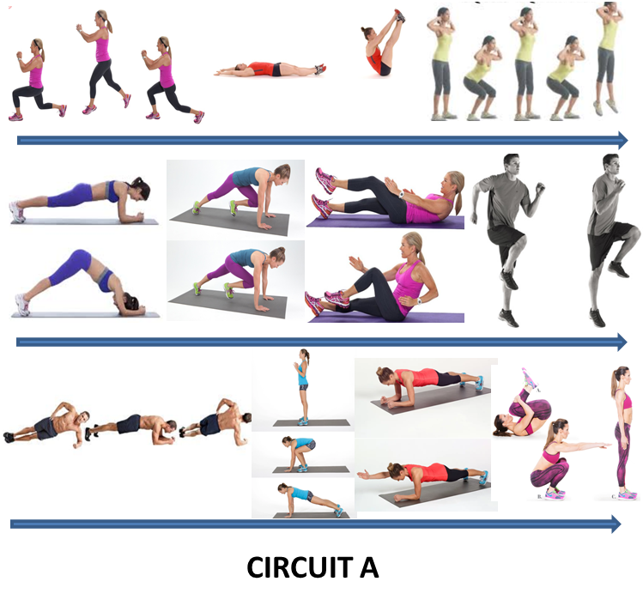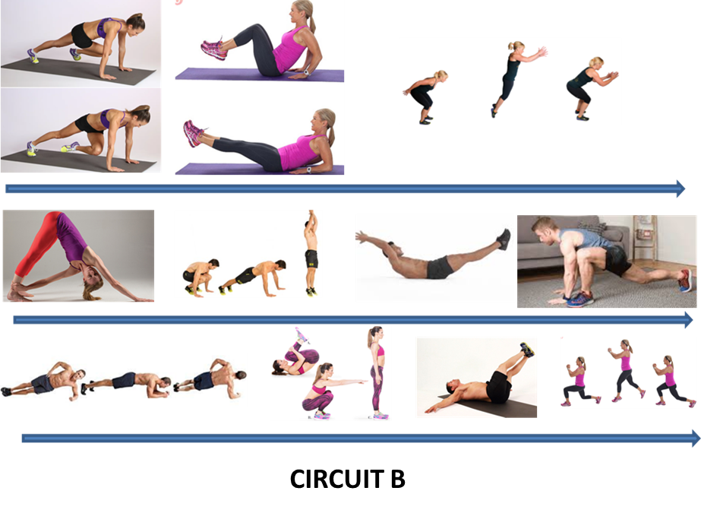

**DISTANCE BASED RECOVERY MODALITIES**

Training at home will provide an alternative stimulus and which brings about the challenge of having to recover from novel stimuli.

With the above in mind, Yoga and Pilates are both effective means to promote recovery from a both a physical and mental perspective. Below a number of resources that provide home-based Yoga and Pilates follow along sessions:

|  |  |
| --- | --- |
| **Yoga** | **Pilates** |
| [Lulu Lemon Yoga YouTube Channel](https://www.youtube.com/playlist?list=PL1A11CDC25D710702) | [Trifecta Pilates YouTube Channel](https://www.youtube.com/channel/UCGyYSva87WwY-XG7VOlYdfg) |
| [Adriene Mishler YouTube Channel](https://www.youtube.com/channel/UCFKE7WVJfvaHW5q283SxchA) | [Jessica Valant YouTube Channel](https://www.youtube.com/channel/UCjP1qqdUt2rRUM3r_4-4MMg) |
| [Peloton App Yoga Sessions (Part of 90 Day Trial)](https://www.onepeloton.co.uk/app) |  |