Into the new season
Newcastle Swim Team have had an extremely successful summer, with our older swimmers winning medals for England & Great Britain, in Georgia and Samoa, and our younger swimmers achieving numerous PBs at our very own summer gala in Tynemouth. In this newsletter we will have updates on all things swimming, from gala reports and skills workshops to new coaching appointments! We will also bring you up to date will all recent developments within the club, including the date of our Christmas Party!

Gala Reports
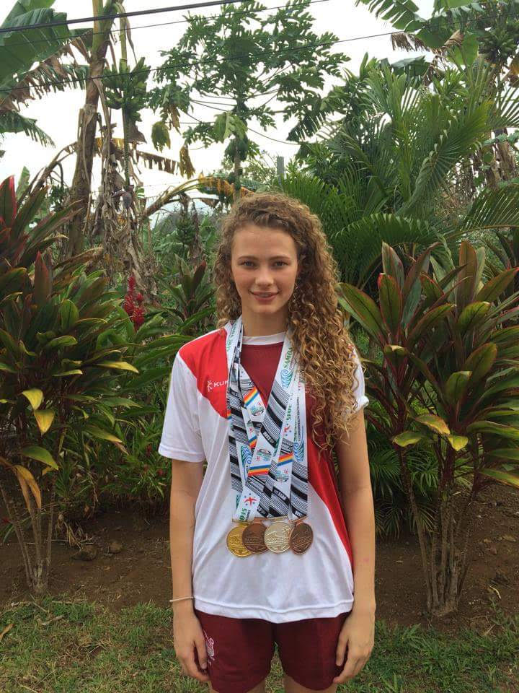
NST have been represented all over the world, with swimmers racing in the UK, Europe and Samoa! Emily Large and Annalea Davison both represented Great Britain at the European Youth Olympic Festival in Tbilisi, Georgia, and came home with medals! Emily picked up a silver in the 200 Butterfly, swiftly added to by Annalea, who grabbed herself a superb bronze in the 400 Freestyle. This was a tremendous achievement for both girls, considering it was their first international competition.
Not to be outdone by her younger counterparts, Georgia Darwent travelled to Samoa, along with the rest of the England team competing at the Commonwealth Youth Games. Georgia came away with four medals; Gold in the 800 Freestyle and Bronze in the 400 Freestyle, followed by Silver in the 4x200 Freestyle Relay and Bronze in the 4x100 Freestyle Relay.
Georgia Darwent: Commonwealth Champion
We also saw a huge number of swimmers competing at the Welsh, English and British Nationals throughout July and August, in swims ranging from 50m all the way through to the gruelling 5KM Open Water event in Rother Valley. Matthew Reay, Angus Waugh and Lowri Waugh trekked down to Swansea for the Welsh Nationals, with all three returning to Newcastle with medals. Over 20 swimmers made the journey to Ponds Forge, Sheffield, for the English and British Nationals. Whilst medals were mostly elusive over the two weeks of racing, the team managed to produce many finalists, with most achieving substantial PBs at this crucial stage of the season.
In June, a large contingent of NST swimmers were part of the North East Team who placed 2nd in the English Schools Inter-Division Championships, held at the Sunderland Aquatic Centre. NST swimmers included Joseph Burrin, Nick Pyle, Will Smith, Angus Waugh, Georgia Darwent, Annalea Davison, Lauren Hodgson, Lucy Howarth, Emily Large and Kate Macphee.
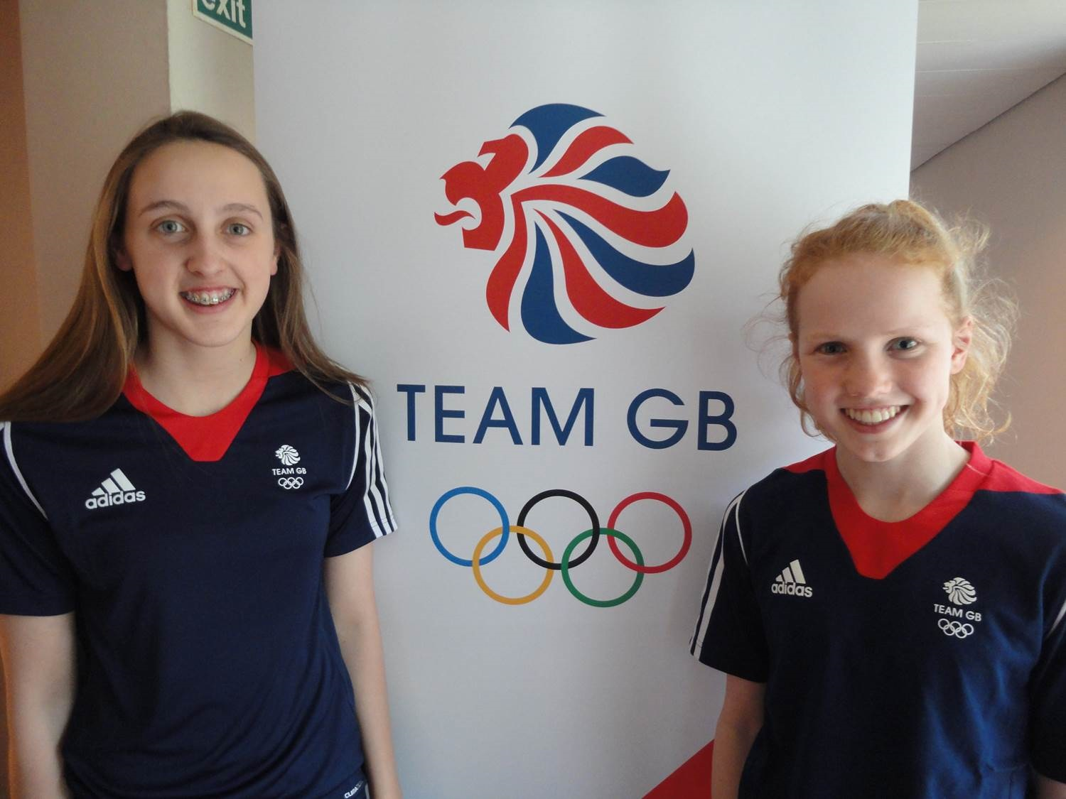
In July, the club held its annual Summer Meet at Tynemouth Pool. The gala proved to be a huge success, with swimmers competing from 9 squads, ranging from national level swimmers through to those who were competing for the first time. The atmosphere was electrifying from start to finish, with an abundance of PBs and plenty of money being won. A special thanks to everyone involved!
EYOF Medallists: Annalea Davison (left) and Emily Large (right)
More recently, the 2015-2016 season has got off to a flying start with three NST swimmers representing England North at the UK Schools Games (Annalea Davison, Emily Large & Will Smith), as well as over 100 NST swimmers racing at the Richmond Dales Back to Pool Meet in Durham. 6 NST swimmers were also part of the North East Team who were crowned English Schools Champions after a pulsating weekend of racing at the Inter-Division Championship 2015/16, Leeds.
Between now and Christmas, whilst it may be getting cold outside, things will really start to heat up in the pool; older swimmers will be aiming for NERs and Winter Nationals, whilst younger swimmers will be competing at our Shrimp Meet in November.

Talent Camp & Team Selections
Congratulations to the following swimmers who have been selected for Talent Camps, English Schools Inter-Division Championships (ESSA) & County Team Championships (Inter Counties):
- England Talent Phase 1: Madelaine Hardingham, Christian Ubanan.
- England Talent Phase 2: Annalea Davison, Emily Large.
- Scottish National Youth Squad: Kate Macphee.
- Advanced Apprenticeship in Sporting Excellence: Lauren Hodgson
- ESSA: Jane Brown, Annalea Davison, Emily Large, Joe Burrin, Nick Pyle, Angus Waugh, Tom Howley (Team Leader).
- Inter Counties: Jane Brown, Annalea Davison, Lauren Hodgson, Nina Holguin, Joe Burrin, Nick Pyle, Will Smith and Ryan Livingstone (Coach).

County Record
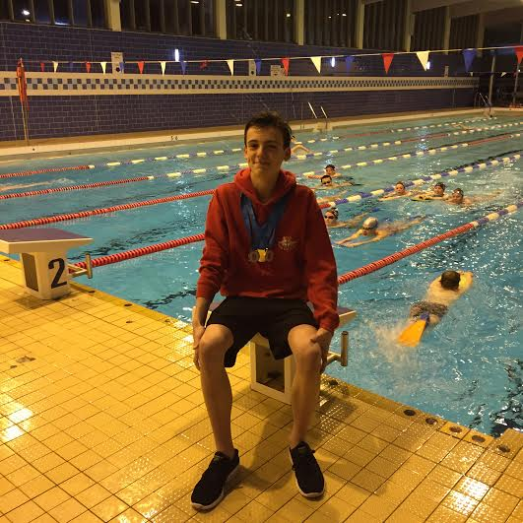
Congratulations to Nick Pyle (14, B squad) who broke the NDSA County Record in the Junior Boys 100m Backstroke during the ESSA Inter-Division Championships in Leeds. The previous record stood at 58.46 (Adam Taylor, City of Sunderland ASC) before being lowered by Nick, by four tenths of a second, to 58.06. This is a tremendous achievement for Nick, whose name is now amongst an illustrious group of N&D swimmers, some of whom have gone on to represent their country at Commonwealth, World and Olympic Games. Hopefully this is one of many short course county records that will fall over the next few months!
Junior Boys 100 BK NDSA County Record: Nick Pyle (14)

Masters Report
Newcastle Swim Team had a successful visit to Harrogate for the North East Region masters championships in September. This was a bigger team than in recent years, comprising: Charlotte Duff, Emily Charlton, Arthur Aplin, Will Jolly, Julian Plumley, Chris Heaps, Eddie Sawyers and Alan Weddell. The highlight of the day was undoubtedly two gold’s in 4x50 Freestyle and 4x50 Medley for the 72+ age category relay comprising Chris, Emily, Charlotte and Will. This was especially pleasing, since it was Emily and Will's first competition in a long while. Welcome back to racing!
In the individual events, results were based on adjusted times - corrected for the age of the swimmer. So swimmers in their twenties and those in their seventies were competing for the same medals, which caused some confusion at first! Julian (50-54) won a gold in the 200 free and two silvers in the 100 and 400. Eddie (over 60) took gold in the 100 breast and a bronze in the 50. Charlotte (18-24) seemed to be competing in almost every race, and came home with three bronze medals in 100 & 200 back and the 100 fly, while Emily won a bronze in the 100 free.
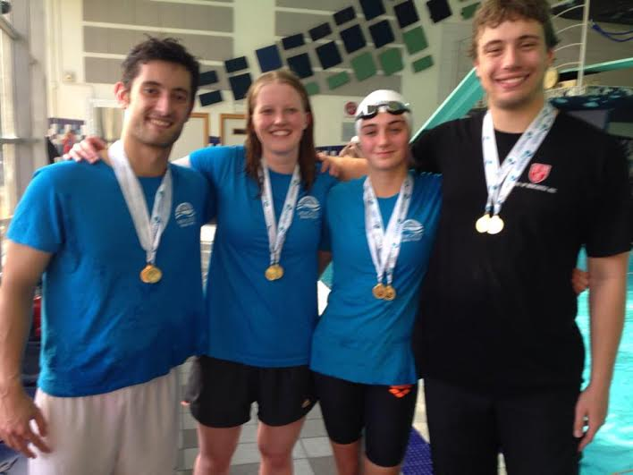
The NERs were the last chance to gain race practice before the ASA masters nationals in Sheffield, on 23/4/5 October. We will be taking our biggest ever team to nationals - 16 swimmers. It's getting close, although still no signs of a taper in training from coach Geoff!
NER Champs: Chris Heaps, Emily Charlton, Charlotte Duff and Will Jolly

Ryan in America
In early September, Head Coach Ryan Livingstone attended the American Swimming Coaches Association Clinic in Cleveland, Ohio. Speakers included Bob Bowman (Coach of Michael Phelps), Bruce Gemmell (Coach of Katie Ledecky) and Eddie Reese (who's swimmers have won the most Olympic Medals). Ryan said of the clinic 'This was a very enjoyable and productive visit, and it was great to get an insight into the training and preparation of the world best swimmers).

Farewell to Alec
October will be Alec Wann’s last month of coaching with Newcastle Swim Team, before he embarks upon a new career in Accountancy. Alec is sad to leave the club but is also excited to start a new chapter within his career.
Having formerly worked with Newburn ASC, Alec was one of the coaches who helped with the formation of NST. Coaching B squad since the clubs inception and, more recently, picking up extra duties including the delivery of land training sessions for C1&C2, education for C1 and Skills Workshops, Alec has been an integral part of the team. We wish him all the best with his future endeavours.

New Coach Appointment
In our last newsletter we revealed plans for the Junior Development Squad. The purpose of this squad was to provide younger swimmers a structured training programme in a less committed environment than that which had been offered in the C squads. Over the past couple of months the squad has grown and is proving to be a real success. Hoping to build on this success is Sam Robertson, who has taken responsibility as lead coach for the squad. Sam will be a familiar face to most, as she also works as swimming teacher at Outer West. Sam will bring tremendous enthusiasm to the squad and, having been a competitive swimmer herself, she will have a wealth of knowledge to share with the swimmers.

Home Galas
The Shrimp Meet is making a welcome return for the 2015-2016 season! This gala will be held at Tynemouth Pool on Sunday 29th November and will be aimed at C & D squad swimmers.
In addition, we have recently secured the NST County Qualifying Meet for the 9th-10th January 2016. This will be held at the notoriously fast pool of Haven Point, South Shields.
Both galas provide an opportunity for our younger swimmers to race competitively, perhaps for the first time, and to post times on the rankings that will allow them to qualify for future competitions.
All upcoming galas are found on our website, which is updated on a regular basis. This can be found by typing www.newcastleswimteam.co.uk into your search engine.

Membership
The club has been steadily growing since coming into existence in 2014 and membership has almost surpassed the 400 mark! Here’s the breakdown:
- Category 1 (non-competitive swimmers) – 66
- Category 2 (competitive swimmers) – 260
- Category 3 (coaches, parents, life members) – 62
- Total – 388 members!
This is an increase on Newburn and CONASC's membership combined in 2014. NST are growing month on month and we could not be happier with how our expansion has gone over the last year.

Skills Workshops
Alec Wann will continue to deliver skills workshops throughout the season. These will be held during school holidays, with the next series of workshops, focusing on Backstroke development, pencilled in for the week commencing Monday 26th October.
If you would like more information about the workshops, please check out the website or email Alec directly (alecmwann@googlemail.com).

Gala Refunds
All gala refunds are processed by our treasurer, Tracey Morrison. If you require a refund, please email Tracey (finance@newcastleswimteam.co.uk) with the following information:
- Swimmers name
- Gala
- Number of events
- Sort code and account number

Christmas Party
Following the success of last year’s party, this years will be held at the Falcons Rugby Club on the 13th December, 6pm to 11pm. The night will be fun for all, with a Disco and Raffle. Hot Food will also be available.
Tickets will be going on sale at the end of October, £5 each (details to follow- please check website).

Volunteers Needed
We are looking to recruit a social events team to take on the task of organising fun events out of the pool, but also to arrange raffles, sell tickets etc. Please come forward if you have time to help.

Social Media
Through twitter and the website, it’s easy to keep up to date with all the latest NST news. The site is useful when looking for club, squad and gala information, whereas twitter is handy for instant updates about training times & venues, swimming articles and all the latest gossip!
We encourage you to use both sources of media to find answers to all your swimming questions. We currently have 150 followers on twitter but, with almost 400 members in the club, we reckon this could be far higher. Follow NST!
- Website: www.newcastleswimteam.co.uk
- Twitter: @NCL_SwimTeam

